Final Project

Taylor Last

12/7/2020

######################  
# Taylor Last  
# Final Project  
######################  
  
library(tidyverse)  
library(lubridate)  
library(usmap)  
library(maptools)  
library(rgdal)  
  
plot_election_results <- function(electoral = F,vote_type = 'total', region = statepop$abbr){  
   
 if (electoral != T && electoral !=F && electoral != TRUE && electoral != FALSE){  
 return('error: invalid input for electoral')  
 }  
   
 # Read in the file and create inperson column votes  
 election_latest <- read_csv('/Users/taylorlast/Documents/UGA_FourthYear/STAT_4365/USElection2020-NYT-Results-master/data/latest/presidential.csv', na = c('','NA',"NULL",'PrivacySuppressed'))  
 election_latest = mutate(election_latest,results_inperson_trumpd = results_trumpd - results_absentee_trumpd,  
 results_inperson_bidenj = results_bidenj - results_absentee_bidenj,  
 inperson_votes = votes - absentee_votes)  
 if(vote_type == 'total'){  
 election=select(election_latest,state,votes,results_trumpd,results_bidenj)  
   
 election_states=group_by(election,state)  
 election_states  
   
 #Total votes by state  
 total_votes=summarise(election_states,sum(votes))  
 total_votes  
   
 #Trump votes  
 trump_votes=summarise(election_states,sum(results_trumpd))  
 trump_votes  
   
 #Biden votes  
 biden_votes=summarise(election_states,sum(results_bidenj))  
 biden_votes  
   
 #Mutate the data frame  
 voting_data=mutate(total_votes,  
 trump = trump_votes$`sum(results_trumpd)`/total_votes$`sum(votes)`,  
 biden = biden_votes$`sum(results_bidenj)`/total_votes$`sum(votes)`,  
 total = `sum(votes)`)  
 }else if (vote_type == 'absentee'){  
 election=select(election_latest,state,absentee_votes,results_absentee_trumpd,results_absentee_bidenj)  
   
 election_states=group_by(election,state)  
 election_states  
   
 #Total votes by state  
 total_votes=summarise(election_states,sum(absentee_votes))  
 total_votes  
   
 #Trump votes  
 trump_votes=summarise(election_states,sum(results_absentee_trumpd))  
 trump_votes  
   
 #Biden votes  
 biden_votes=summarise(election_states,sum(results_absentee_bidenj))  
 biden_votes  
   
 #Mutate the data frame  
 voting_data=mutate(total_votes,  
 trump = trump_votes$`sum(results_absentee_trumpd)`/total_votes$`sum(absentee_votes)`,  
 biden = biden_votes$`sum(results_absentee_bidenj)`/total_votes$`sum(absentee_votes)`,  
 total = `sum(absentee_votes)`)  
 }else if (vote_type == 'in-person'){  
 election=select(election_latest,state,inperson_votes,results_inperson_trumpd,results_inperson_bidenj)  
   
 election_states=group_by(election,state)  
 election_states  
   
 #Total votes by state  
 total_votes=summarise(election_states,sum(inperson_votes))  
 total_votes  
   
 #Trump votes  
 trump_votes=summarise(election_states,sum(results_inperson_trumpd))  
 trump_votes  
   
 #Biden votes  
 biden_votes=summarise(election_states,sum(results_inperson_bidenj))  
 biden_votes  
   
 #Mutate the data frame  
 voting_data=mutate(total_votes,  
 trump = trump_votes$`sum(results_inperson_trumpd)`/total_votes$`sum(inperson_votes)`,  
 biden = biden_votes$`sum(results_inperson_bidenj)`/total_votes$`sum(inperson_votes)`,  
 total = `sum(inperson_votes)`)  
 }else{  
 return('error: invalid vote type')  
 }  
  
 voting_data = voting_data[c('state','trump','biden','total')]  
   
 voting_data = mutate(voting_data, trump_win = ifelse(voting_data$trump > voting_data$biden,1,0))  
   
 # Get the centers for each state  
 state_centers = usmap_transform(tibble(state.center$x, state.center$y,state.name))  
   
 # Read in our electoral dataframe  
 electoral_votes <- read_csv('/Users/taylorlast/Documents/UGA_FourthYear/STAT_4365/electoralvotes.csv')  
   
 # Data Frame allows us to calculate electoral votes with DC  
 electoral_college = merge(voting_data,electoral_votes, by ='state')  
 electoral_college = mutate(electoral_college,abbr = statepop$abbr)  
 electoral_college = filter(electoral_college, abbr %in% region)  
 electoral_biden = sum(electoral_college$`number of votes`) - sum((electoral_college$`number of votes`)*(electoral_college$trump_win))  
 electoral_trump = sum((electoral_college$`number of votes`)*(electoral_college$trump_win))  
   
 # Remove DC because it doesn't have values for center  
 electoral_votes = electoral_votes[-9,]  
 electoral_votes = mutate(electoral_votes,center_long = state_centers$state.center.x.1, center_lat = state_centers$state.center.y.1)  
   
 # Change the center for Alaska and Hawaii  
 electoral_votes[2,3]=-1203560  
 electoral_votes[2,4]=-1837070  
 electoral_votes[11,3]=-450000  
 electoral_votes[11,4]=-2130070  
   
 voting_data = mutate(voting_data, state = statepop$full, abbr = statepop$abbr)  
 electoral_votes = mutate(electoral_votes,state = state.name)  
 election_results = merge(voting_data,electoral_votes, by = 'state')  
   
 #Filter by region - will make sure electoral votes don't show for out of region  
 election_results = filter(election_results,abbr %in% region)  
   
 if (electoral == F){  
 plot_usmap(data = election_results, regions = 'states',values = 'trump',include = region) +  
 scale_fill_continuous(low = 'white', high = 'red', name = 'Vote Percentage for Trump')+  
 theme(legend.position = "right") +  
 ggtitle(paste(vote_type, 'popular vote based on the latest update since the election'))+  
 theme(plot.title = element_text(size = 12, face = "bold"))  
 }else {  
 plot_usmap(data = election_results,regions = 'states', values = 'trump_win', include = region) +  
 scale_fill_continuous(low= 'blue',high = 'red', labels = c('Biden','Trump'), breaks = c(0,1), name = 'Candidate',guide = 'legend') +  
 geom_text(data=election_results,aes(x=center_long,y=center_lat,label = `number of votes`)) +  
 theme(legend.position = 'right') +  
 ggtitle(paste('Biden:', electoral_biden,  
 'Electoral Votes\nTrump:', electoral_trump,  
 'Electoral Votes\nBased on the latest update since the election'))+  
 theme(plot.title = element_text(size = 12, face = "bold"))  
 }  
}

#Test cases  
plot_election_results(electoral = T, vote_type = 'total')

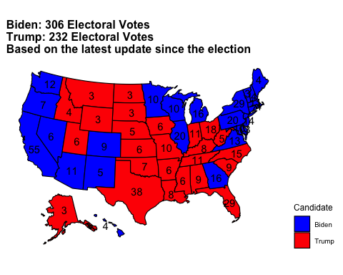

plot_election_results(electoral = T, vote_type = 'total', region = .south_region)

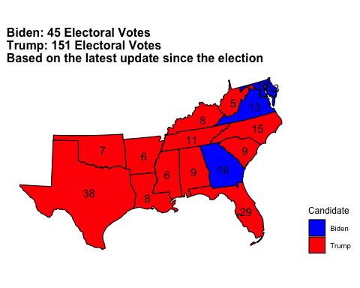

plot_election_results(electoral = F, vote_type = 'total')

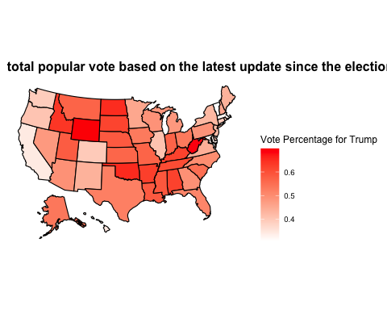

plot_election_results(electoral = F, vote_type = 'absentee')

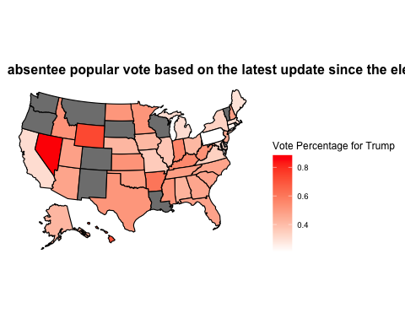

plot_election_results(electoral = F, vote_type = 'in-person')

